**16. Develop a wireframe for a mobile application that addresses challenges related to ad hoc wireless networks using Figma.**

**Aim: -**

Create a Wireframe for a mobile application that addresses challenges related to ad hoc wireless networks using Figma.

**Procedure: -**

1. open Figma

2. Create a new file

3. Select the Frames

4. Design Visual Elements

5. Make it Interactive

6. Add icons on the Frame

7. Incorporate Multimedia

8. Storyboard Animation

9. Review and edit the Prototype

10. Save and Share

**Design: -**

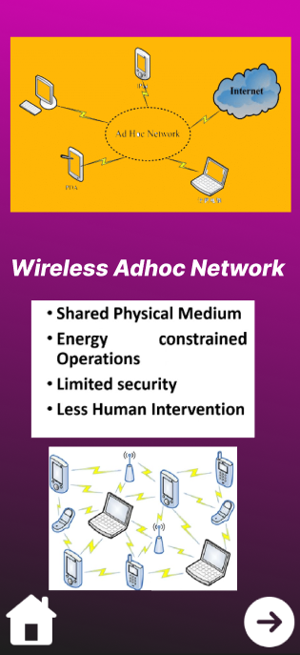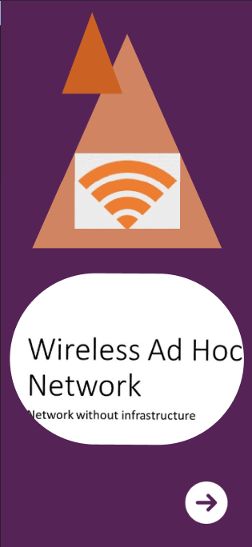

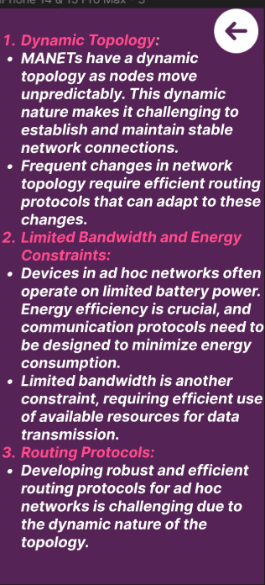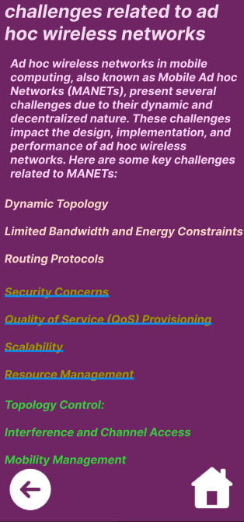

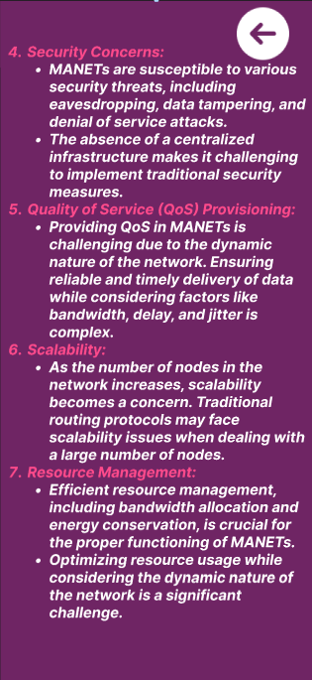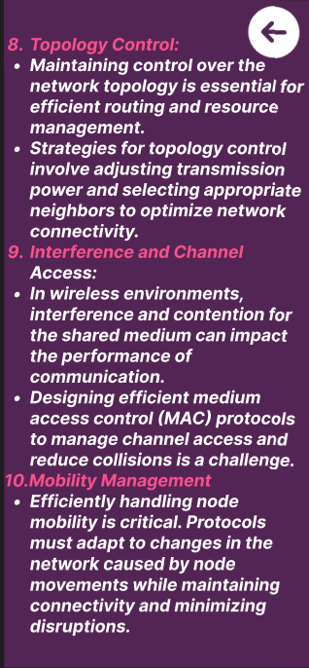

**Prototype: -**

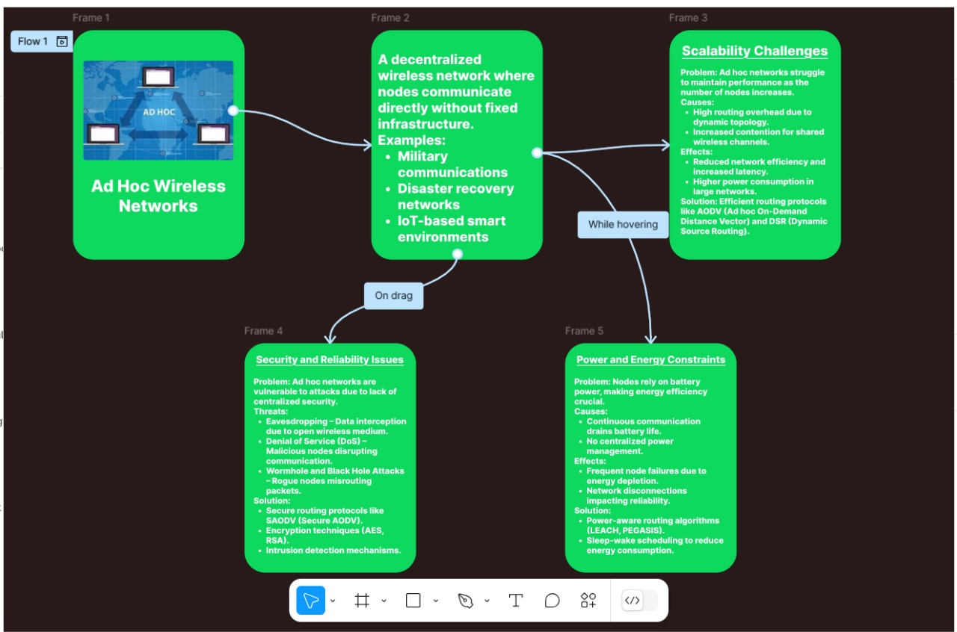

**Result: -**

Hence a wireframe for a mobile application that addresses challenges related to ad hoc wireless networks using Figma is created and executed successfully